- KPIs
- Total revenue
select SUM(total_price) As total_revenue from pizza_sales
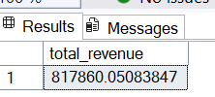
- Average order value
SELECT SUM(total_price) / COUNT(DISTINCT order_id) AS Avg_order_value from pizza_sales
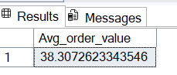
- Total pizza sold
SELECT SUM(quantity) As Total_pizza_sold from pizza_sales
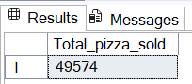
- Total ordes
SELECT COUNT(DISTINCT order_id) AS Total_orders from pizza_sales
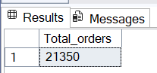
- Average pizza per order
SELECT CAST(CAST(SUM(quantity) AS DECIMAL(10,2)) /
CAST(COUNT(DISTINCT order_id) AS DECIMAL(10,2)) AS DECIMAL(10,2)) As Avg_pizza_per_order from pizza_sales
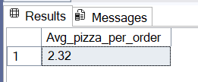
- Charts requirements
- Daily trend for total orders
SELECT DATENAME(DW, order_date) AS order_day, COUNT(DISTINCT order_id) AS total_orders
from pizza_sales
GROUP BY DATENAME(DW, order_date)
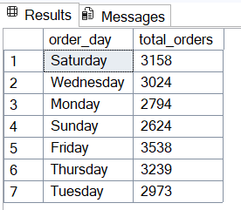
- Monthly trend for total orders
SELECT DATENAME(Month, order_date) AS month_name, COUNT(DISTINCT order_id) AS total_orders
from pizza_sales
GROUP BY DATENAME(Month, order_date)
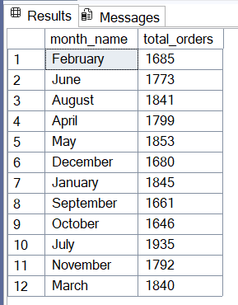
- Percentage of sales by pizza category
SELECT pizza_category, SUM(total_price) * 100 / (SELECT SUM(total_price) from pizza_sales) AS
perc_sales_per_pizza_category from pizza_sales
GROUP BY pizza_category
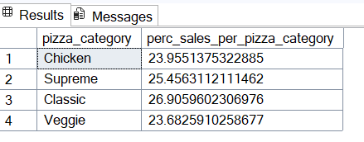
- Percentage of sales per pizza size
SELECT pizza_size, CAST(SUM(total_price) * 100 / (SELECT SUM(total_price) from pizza_sales)AS DECIMAL(10,2)) AS
perc_sales_per_pizza_size from pizza_sales
GROUP BY pizza_size
ORDER BY perc_sales_per_pizza_size DESC
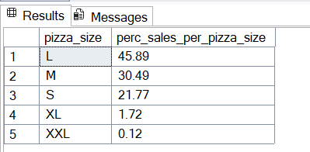
- Top 5 pizzas by revenue
SELECT TOP 5 pizza_name, SUM(total_price) AS total_revenue from pizza_sales
GROUP BY pizza_name
ORDER BY total_revenue DESC
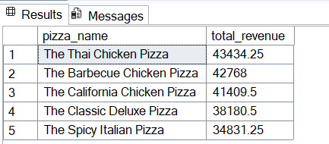
- Bottom 5 pizzas by revenue
SELECT TOP 5 pizza_name, SUM(total_price) AS total_revenue from pizza_sales
GROUP BY pizza_name
ORDER BY total_revenue
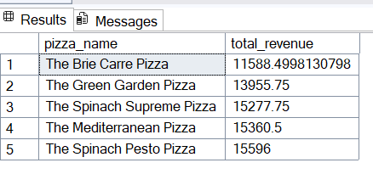
- Best 5 seller pizzas
SELECT TOP 5 pizza_name, COUNT(quantity) AS total_orders from pizza_sales
GROUP BY pizza_name
order by total_orders DESC
